**Notes for Slide 01: Introduction to Programming**

5/14/14

1. **Programming Tools**
   * **The Computer**
   * **The Operating System**
   * **The Integrated Development Environment**
     + The Code Editor
     + The Compiler
     + The Debugger
   * **Problem Solving Skills**
   * **Language Skills**
2. **The Computer**

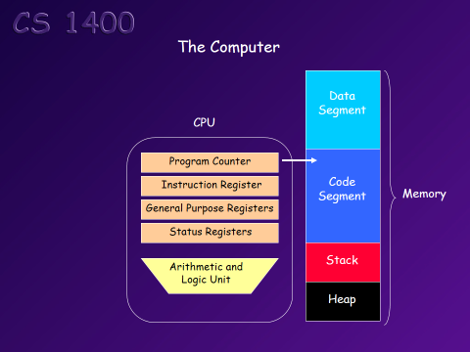

**CPU-**

* Program Counter
* Instruction Register
* General Purpose Registers
* Status Registers
* **Arithmetic & Logic Unit (ALU)**

**Memory-**

* Data Segment
* Code Segment
* Stack
* Heap

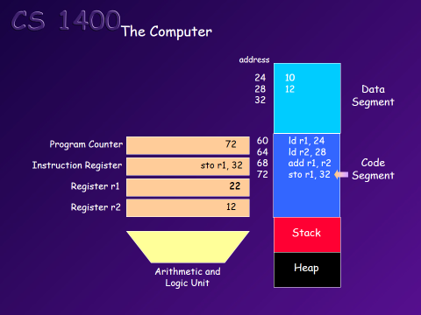Example of how a Computer adds 2 numbers together, step-by-step.

1. The program to be executed is stored in the **Code Segment.**
2. The data is stored in the **Data Segment.**
3. The **Program Counter** points to the next instruction to be executed.

**\*The Data Segment** stores the data in addresses.

**\*The Code Segment** uses procedure data that is also stored in an addresses to be used for executing the program.

**\*Stack-**

**\*Heap-** left over memory, not being used by any program. It is managed by the O/S

**\*Arithmetic and Logic Unit (ALU)-**

**\*Program Counter-**

**\*Instruction Register-**

**\*Register-**

1. **The Operating System**

* Manages the memory in the computer
* Manages how and when programs are executed
* Manages the devices attached to the computer
* Manages everything else the computer does

**The Code Editor**

* Provides a way for the programmer to create and edit the **Source Code** text for the program
  + **Source Code-**

**The Compiler**

Definition-

**Integrated Development Environment (IDE)**

* A code editor
* a Compiler
* a Debugger
* and other development tools

**Overview of Source Code Being Executed and its Position in the O/S**

